Http Observables in Angular

**What is Observable**

”Observables provide support for passing messages between publishers and subscribers in your application. Observables offer significant benefits over other techniques for event handling, asynchronous programming, and handling multiple values.— from [*Angular.io*](https://angular.io/guide/observables)”

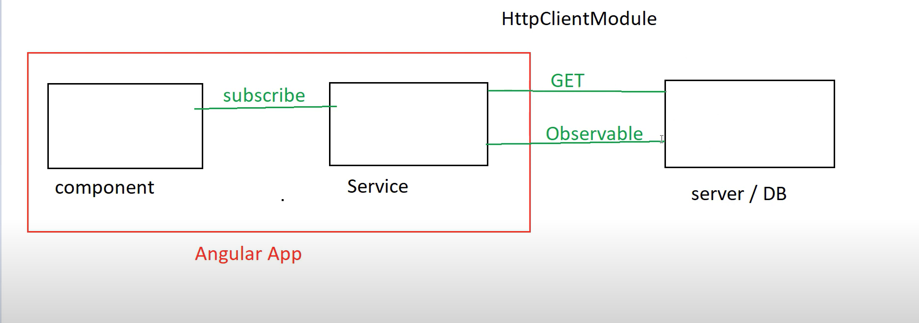

Step :1

<https://jsonplaceholder.typicode.com/>

step :2 userlist Component

step 3 :user Service

step 4 :User Model 🡺 interface 🡺 tools 🡺interface json 🡺

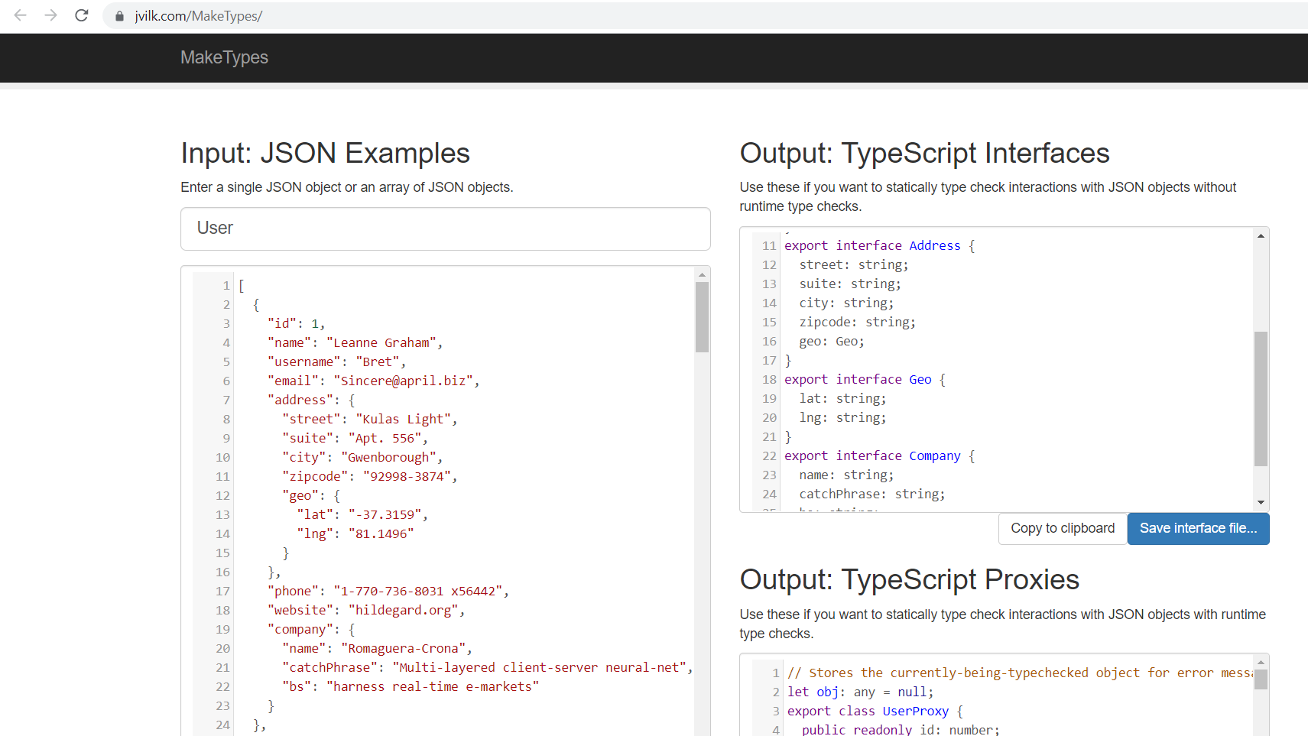

Create folder 🡺 Models🡺 User.ts 🡺 paste the copied code from above image.

Create a user-list Component

ng g c user-list

create a service

ng g s user

app.component.html

<app-user-list></app-user-list>

App.Module.ts

import { NgModule } from '@angular/core';

import { BrowserModule } from '@angular/platform-browser';

import { AppRoutingModule } from './app-routing.module';

import { AppComponent } from './app.component';

import { UserListComponent } from './user-list/user-list.component';

import {HttpClientModule} from '@angular/common/http';

@NgModule({

  declarations: [

    AppComponent,

    UserListComponent

  ],

  imports: [

    BrowserModule,

    AppRoutingModule,

    HttpClientModule

  ],

  providers: [],

  bootstrap: [AppComponent]

})

export class AppModule { }

goto user.service.ts

import { HttpClient } from '@angular/common/http';

import { Injectable } from '@angular/core';

import { Observable } from 'rxjs';

@Injectable({

  providedIn: 'root'

})

export class UserService {

  constructor(private httpClient:HttpClient) { }

  public getUsers(){

    let dataURL:string='https://jsonplaceholder.typicode.com/users';

    return this.httpClient.get(dataURL);

  }

}

import { HttpClient } from '@angular/common/http';

import { Injectable } from '@angular/core';

import { Observable } from 'rxjs';

import{User} from './Models/User';

@Injectable({

  providedIn: 'root'

})

export class UserService {

  constructor(private httpClient:HttpClient) { }

  public getUsers():Observable<User[]>{

    let dataURL:string='https://jsonplaceholder.typicode.com/users';

    return this.httpClient.get<User[]> (dataURL);

  }

}

Goto user-list -component and subscribe the data from service .

import { Component, OnInit } from '@angular/core';

import {User} from '../Models/User';

@Component({

  selector: 'app-user-list',

  templateUrl: './user-list.component.html',

  styleUrls: ['./user-list.component.css']

})

export class UserListComponent implements OnInit {

public users:User[]=[] as User[];

  constructor() { }

  ngOnInit(): void {

  }

}

Userlist.compnent.html

<p>user-list works!</p>

<pre> {{users |json}}</pre>

import { Component, OnInit } from '@angular/core';

import {User} from '../Models/User';

import { UserService } from '../user.service';

@Component({

  selector: 'app-user-list',

  templateUrl: './user-list.component.html',

  styleUrls: ['./user-list.component.css']

})

export class UserListComponent implements OnInit {

public users:User[]=[] as User[];

  constructor(private userservice:UserService) { }

  ngOnInit(): void {

     this.userservice.getUsers().subscribe((data:User[]) =>

     this.users=data);

  }

User-list.component.html

<section>

    <div class="container">

        <div class="row">

            <div class="col">

            <p class="h3 text-danger">User List</p>

            <p> Lorem ipsum dolor sit amet consectetur adipisicing elit. Vitae quisquam omnis quam sit maxime exercitationem fugiat dolorum debitis iste dolore numquam libero error minima, ullam fugit perferendis odio ea dolores?</p>

            <!-- <button class="btn btn-success btn-sm" (click)="getuserData()"> Get Users</button> -->

            </div>

        </div>

    </div>

</section>

<section>

    <div class="container">

    <div class="row">

        <div class="col">

            <table class="table table-hover text-center tble-striped">

                <thead>

                    <tr>

                        <th> sno</th>

                        <th>Name</th>

                        <th>Email</th>

                        <th>Website</th>

                    </tr>

                </thead>

                <tbody>

                    <tr *ngFor="let user of users">

                        <td>{{user.id}}</td>

                        <th>{{user.name}}</th>

                        <th>{{user.email}}</th>

                        <th>{{user.website}}</th>

                    </tr>

                </tbody>

            </table>

        </div>

    </div>

</div>

</section>

Index.html

<!doctype html>

<html lang="en">

<head>

  <meta charset="utf-8">

  <title>HttpObservableExample</title>

  <base href="/">

  <meta name="viewport" content="width=device-width, initial-scale=1">

  <link rel="icon" type="image/x-icon" href="favicon.ico">

  <!-- Latest compiled and minified CSS -->

<link rel="stylesheet" href="https://maxcdn.bootstrapcdn.com/bootstrap/3.3.7/css/bootstrap.min.css" integrity="sha384-BVYiiSIFeK1dGmJRAkycuHAHRg32OmUcww7on3RYdg4Va+PmSTsz/K68vbdEjh4u" crossorigin="anonymous">

<!-- Optional theme -->

<link rel="stylesheet" href="https://maxcdn.bootstrapcdn.com/bootstrap/3.3.7/css/bootstrap-theme.min.css" integrity="sha384-rHyoN1iRsVXV4nD0JutlnGaslCJuC7uwjduW9SVrLvRYooPp2bWYgmgJQIXwl/Sp" crossorigin="anonymous">

<!-- Latest compiled and minified JavaScript -->

<script src="https://maxcdn.bootstrapcdn.com/bootstrap/3.3.7/js/bootstrap.min.js" integrity="sha384-Tc5IQib027qvyjSMfHjOMaLkfuWVxZxUPnCJA7l2mCWNIpG9mGCD8wGNIcPD7Txa" crossorigin="anonymous"></script>

</head>

<body>

